***+ANUDIP FOUNDATION***

A Project Report on

**FLIGHT BOOKING SYSTEM**

By

Batch: ANP-D0453

Student ID: AF0477070

Name: Shweta Ankalgi

**Under the Guidance of**

Mrs. Rajshri Chandrabhan Thete

FLIGHT BOOKING SYSTEM

Introducing our Java-based Flight Booking System (RMS):

A flight booking system is a software application that allows users to search for, book, and manage airline tickets. It streamlines the process of booking flights by providing real-time availability, pricing, and ticketing options. The system is widely used by airlines, travel agencies, and online travel portals to enhance customer convenience and operational efficiency.

**Entities:**

* Admin
* Passenger
* Flight
* Booking
* Airport
* Payment

**ATTRIBUTES OF ENTITIES:**

1. **Admin**

* Attributes:
* admin_id (primary key)
* admin_name
* admin_Email
* admin_password

1. **User (Passenger)**

* Attributes:
* passenger_id (primary key)
* passenger_name
* Phone number
* passenger_Email

1. **Flight**

* Attributes:
* flight_id (primary key)
* airlineName
* source
* destination
* departure Time
* arrival time
* total seats
* available seats
* price

1. **Booking**

* Attributes:
* booking_id (primary key)
* passenger_id (foreign key)
* flight_id (foreign key)
* booking date
* status(confirmed/pending/cancelled)
* payment_id (foreign key)

1. **Airport**

* Attributes:
* airport_id (primary key)
* name
* location
* code

1. **Payment**

* Attributes:
* payment_id (primary key)
* booking_id (foreign key)
* date
* amount
* payment_method
* status (successful/ failed)

**ENTITY RELATIONSHIP DIAGRAM – FLIGHT BOOKING SYSTEM**

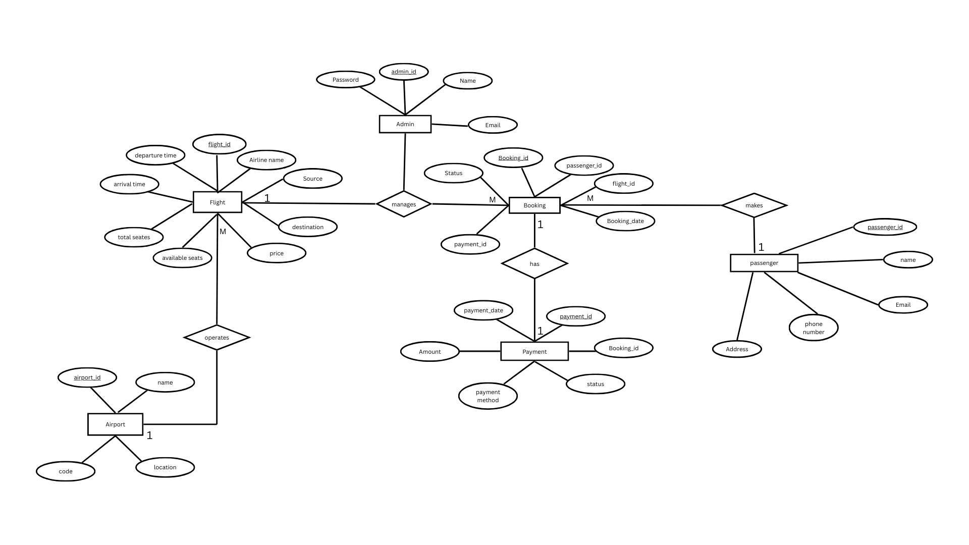

**CONCLUSION:**

In summary, a Flight Booking System provides a comprehensive solution designed to streamline the process of searching, booking, and managing airline tickets, enhancing the travel experience for both passengers and airline operators. By automating critical operations such as flight scheduling, seat reservations, payment processing, and cancellation handling, the system significantly improves efficiency and accuracy in airline management. This system enhances communication between airlines and passengers, ensuring seamless booking experiences and reducing errors in ticketing and scheduling. Additionally, by offering real-time access to essential information such as flight availability, pricing, and customer preferences, it enables airlines and travel agencies to make informed business decisions that enhance customer satisfaction and operational performance. Overall, a Flight Booking System plays a crucial role in modernizing the airline industry, improving service quality, and ensuring a hassle-free travel experience for passengers while optimizing business operations for airlines and travel agencies.

**DATABASE CREATION QUERY:**

**Query OK, 1 row affected (0.01 sec)**

**mysql> CREATE TABLE Admin (**

**-> Admin_ID VARCHAR(20) PRIMARY KEY,**

**-> Name VARCHAR(100) NOT NULL,**

**-> Email VARCHAR(100) UNIQUE NOT NULL,**

**-> Password VARCHAR(100) NOT NULL**

**-> );**

**mysql> CREATE TABLE passenger (**

**-> passenger_id INT AUTO_INCREMENT PRIMARY KEY,**

**-> name VARCHAR(100) NOT NULL,**

**-> phone VARCHAR(15),**

**-> email VARCHAR(100) UNIQUE NOT NULL,**

**-> password VARCHAR(100) NOT NULL**

**-> );**

**Query OK, 0 rows affected (0.02 sec)**

**mysql> CREATE TABLE flight (**

**-> flight_id INT AUTO_INCREMENT PRIMARY KEY,**

**-> airline_name VARCHAR(100) NOT NULL,**

**-> source VARCHAR(100) NOT NULL,**

**-> destination VARCHAR(100) NOT NULL,**

**-> departure_time VARCHAR(50),**

**-> arrival_time VARCHAR(50),**

**-> total_seats INT NOT NULL,**

**-> available_seats INT NOT NULL**

**-> );**

**Query OK, 0 rows affected (0.03 sec)**

**mysql> CREATE TABLE airport (**

**-> airport_id INT AUTO_INCREMENT PRIMARY KEY,**

**-> airport_name VARCHAR(100) NOT NULL,**

**-> code VARCHAR(10) UNIQUE NOT NULL,**

**-> location VARCHAR(100) NOT NULL,**

**-> );**

**Query OK, 0 rows affected (0.03 sec)**

**mysql> CREATE TABLE payment (**

**-> payment_id INT AUTO_INCREMENT PRIMARY KEY,**

**-> amount DOUBLE NOT NULL,**

**-> payment_method VARCHAR(50),**

**-> payment_date DATE,**

**-> status ENUM('Successful', 'Pending', 'Failed') DEFAULT 'Pending'**

**-> );**

**Query OK, 0 rows affected (0.03 sec)**

**mysql> CREATE TABLE booking (**

**-> booking_id INT AUTO_INCREMENT PRIMARY KEY,**

**-> user_id INT,**

**-> flight_id INT,**

**-> airport_id INT,**

**-> booking_date DATE,**

**-> status ENUM('Confirmed', 'Pending', 'Cancelled') DEFAULT 'Pending',**

**-> payment_id INT**

**-> FOREIGN KEY (user_id) REFERENCES passenger(passenger_id),**

**-> FOREIGN KEY (flight_id) REFERENCES flight(flight_id),**

**-> FOREIGN KEY (airport_id) REFERENCES airport(airport_id),**

**-> FOREIGN KEY (payment_id) REFERENCES payment(payment_id)**

**-> );**

**Query OK, 0 rows affected (0.04 sec)**

**mysql> CREATE TABLE Tables (**

**-> Table_number INT PRIMARY KEY,**

**-> Total_people INT,**

**-> Time TIMESTAMP,**

**-> customer_id INT,**

**-> item_id INT,**

**-> order_id INT,**

**-> FOREIGN KEY (customer_id) REFERENCES Customers(customer_id),**

**-> FOREIGN KEY (item_id) REFERENCES Items(item_id),**

**-> FOREIGN KEY (order_id) REFERENCES Orders(order_id)**

**-> );**

**Query OK, 0 rows affected (0.04 sec)**

**mysql> show tables;**

**+---------------+**

**| Tables_in_fbs |**

**+---------------+**

**| admin |**

**| airport |**

**| booking |**

**| flight |**

**| passenger |**

**| payment |**

**+---------------+**

**6 rows in set (0.06 sec)**